How To:

1. Download Android Studio  
   <https://developer.android.com/studio/index.html>
2. Launch the downloaded .exe and follow the setup wizard
3. Open an existing Android Studio project 🡪 Demo_v1
4. Go to Tools (top bar) 🡪 Android   
    🡪AVD Manager
5. Press Create Virtual Device on the bottom right
6. Select Nexus 6p 🡪 API Level 25   
    || || 🡪 Enter a custom name  
    || 🡪 Finish
7. Now you can run the app using Shift+f10 or pressing the play button on the toolbars at the top.  
   Select the newly created emulator as deployment target

Running the App

1. Press the camera button (top right) to select or take a picture to be used in the app
2. Click and drag around the image to find a suitable background color for removal.  
   It won't be exact because it's hardcoded at the moment (don't go outside boundaries!)
3. Press the play button for background removal and dewarping based on chessboard pattern  
   Once it's finished, an image will appear below with the background removed
4. The square button saves the separate fragments on the SD card
5. The last button will display the separate fragments on a new screen.

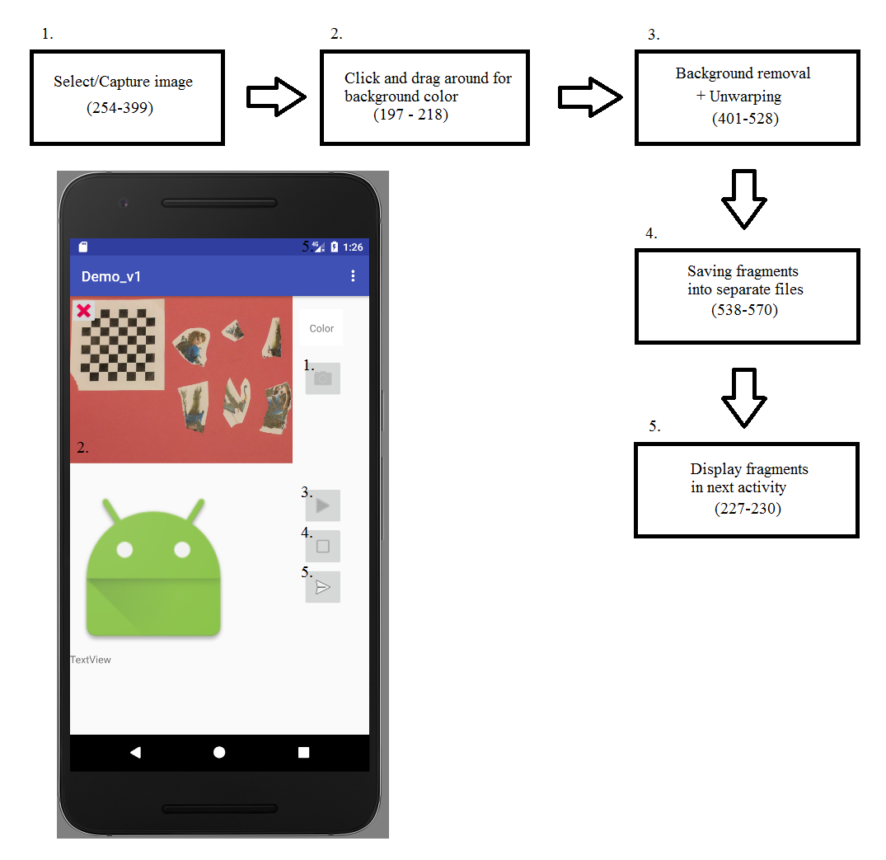

Inserting an image into Emulator:

1. Make sure the emulator is turned on already
2. Tools 🡪 Android

🡪 Android Device Monitor

1. Select the folder named sdcard
2. On the top right there are 4 buttons (the two on the right are - and + symbols).  
   Select the second button (when hovering over it should say "Push a file onto the device")  
   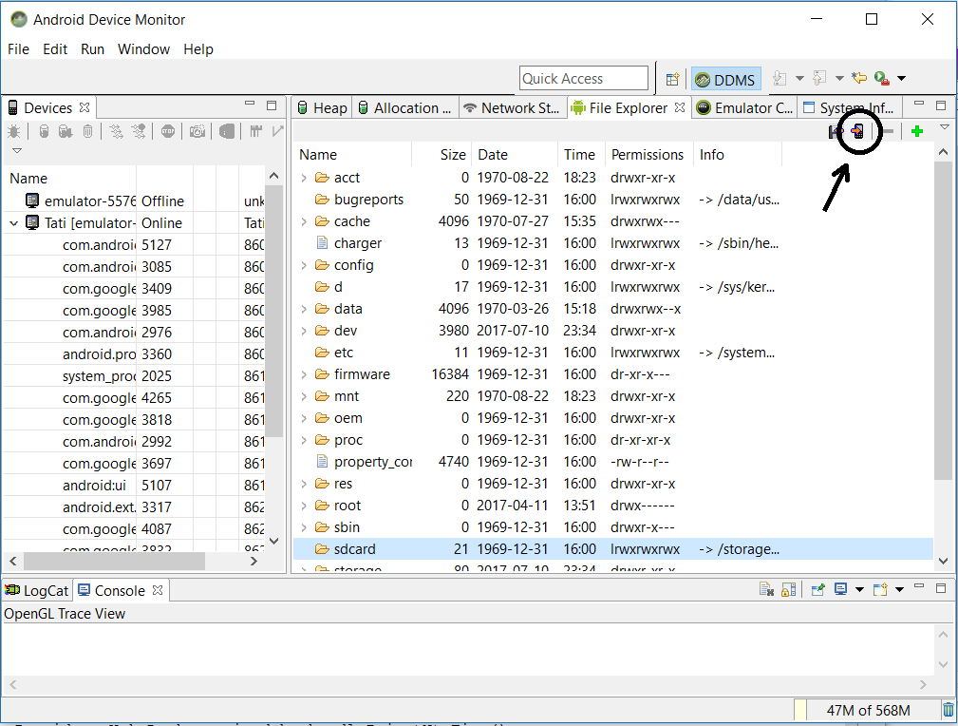  
   Find the image you want to insert on your computer
3. It may take time for the image to load into the emulator's gallery